**FACULTY OF SCIENCE, ENGINEERING AND COMPUTING**

**School of *Computer Science & Mathematics***

**BSc DEGREE**

**IN**

***Computer Science (Software Engineering) Top Up***

**PROJECT PROPOSAL**

Name: **Mohamed Fariq Abdulla Sabith**

ID Number: **E026503**

Project Title: **Leisure Diary**

Project Type: **Build**

Date: **17.01.2023**

Supervisor: Prof. Ruvan Abeysekara

PhD(Doc.Eng.), MSc(CS), BSc,Dip.(Tec.Sc.)

DFA, MBCS, MCS, MIEEE, MIEEECS, MIET, MIDES

KU London Logo

Did you discuss and agree the viability of your project idea with your supervisor? Yes

Did you submit a draft of your proposal to your supervisor? Yes

Did you receive feedback from your supervisor on any submitted draft? Yes

**Abstract**

Leisure Diary is a solution proposed by AFADAMAD (Pvt) Ltd, a travel agent that aims to assist travelers with their inbound and outbound travel needs to ensure their satisfaction by providing a hassle-free, all-in-one trip organizer. The solution offers a wide range of features that reduce the workload of the organizer and provide the required resources at their fingertips. It provides a convenient platform for all the requirements of a traveler and offers an opportunity for related stakeholders to grow their businesses. This report contains all the details about the technologies, methodologies, work plan, constraints, and ways to overcome them.

Contents

1. Introduction & Background 7

1.1 Introduction 7

1.3 Background and Motivation 7

1.4 Problem in brief 8

2. Aim & Objectives 9

1.2.1 Aim 9

1.2.2 Objectives 9

3. Technologies & Resources 9

3.1 Technologies Used 9

3.2 Resource Requirement 10

4. Methodology & Work plan 11

5. Proposed Solution 13

5.1 Suggested Starting Point 16

6. Discussion 16

7. References 17

Appendices 17

**List of Figures/Tables**

Figure 1 System Development Life Cycle 12

Figure 2- Gantt Chart 12

Figure 3- ER Diagram 14

Figure 4 - Project Proposal Approval by supervisor 17

**Glossary of Terms**

HTML: Hyper Text Markup Language  
IDE: Integrated Development Environment  
CSS: Cascading Style Sheet

RAM: Random Access Memory

JS: JavaScript

API: Application Programming Interface

# Introduction & Background

## 1.1 Introduction

AFADAMD (Pvt) Ltd, is a travel agent who assists travelers with their inbound and outbound travel needs, also a trip advisor who works to make sure that travelers are always satisfied. The company's aim is to provide a hassle-free travel experience to all travelers who engage with them. The company has a huge network of hotels, resorts, other leisure activities, and related services in their chain. Over the year the growth of the tourism is immersing. Where all the economic aspects of the countries, business and persons are involving into its impact. However, country and the related business has to involve in improving the tourism industry. This project is to achieve above and to mitigate the problems faced by the travelers and other related business entities in an effective communication. The primary scope of the project is to provide all in one solution to plan and organize trip related aspect without any hassle. Also, to works as a pillar to an effective communication between stakeholders.

## 1.3 Background and Motivation

People are hassling in their daily life. Trips are the one of the method people used to spend their valuable time with their family and get their mind relaxed. Drafting a plan for a trip sometimes can be addressed as a tough task based on the associated entities. Business is also considered as a stakeholder of trips where it has an immense involvement for the tourism sector.

Mostly, the people have turned to search their travel companions through the mobile. Where the majority of the internet users are from their mobile devices. It witnesses that reaching the travelers through mobile application is the best possible way. There are number of troubles possibly faced by the foreign travelers can be wase with a proper communication to reach them [1]. There are many numbers of application available in the market, yet an effective all in one application isn’t in the market. Using separate application for each entity wouldn’t connect them together. Travelers and organizers always intend to find their convenient through such activities which can be provided by an application. Hence it helps us to achieve the ultimate goal which is customer satisfaction. On a large scale of trip organizations involves many numbers of tasks which drop the organizer to engage in the arrangement of the trip while others are enjoying the trip. Tourism service chain is improving day by day. Tourism associates to a major part of a country’s economy. To interact the tourism supply chain together to improve each sector with their involvement.

The primary intension of mobile or any other type of development is user experience (UX), value of the application improves by the user-friendly user experience and its concept. User always expect the solution to be more convenient to use. Therefore, solution providers must evaluate the user requirement as an initial task. Also, it helps to attract new users to the solution [2].

## 1.4 Problem in brief

Planning a trip could be a complex process depending on the people or their interests. The process involves many tasks such as searching and picking a location, arranging transport, finding accommodation, arranging food, and other day wise activities throughout the trip. Many people relucted to involve in planning process since its ultimate goal is to satisfy the co-travelers with their expectations. People who hassle most of the time find a trip as a way to relax their self’s.

Mainly identified problem is that the people who are involved in the planning process are always engaged in the arrangements of stuff while others enjoy the trip. For further extent planning a trip with more people are always a tough assignment. Such as corporate trips, School or university trips etc. involves many numbers of people as travelers. Arranging transportation accommodation and other stuff is an uphill battle.

Currently in the market we have application who provides booking services for hotels, transport and foods. But we don’t have a solution to find all the requirements and share the whole plan with the service providers where we don’t have to meet a hassle while on the trip.

# Aim & Objectives

### 1.2.1 Aim

The aim of this project is to develop an all-in-one mobile application to plan, organize and review a hassle-free trip to travelers’ solution with all the related stakeholder involvement.

### 1.2.2 Objectives

* To identify and provide all in one solution to the travelers to address all their needs through one application.
* To suggest recommendations for the travelers to get decisions on planning a trip.
* To design an application which can find fulfill all the aspects of needs of all the stakeholders.
* To build a communication and interaction method between travelers, service providers and the organizers.

# 3. Technologies & Resources

Primary technology to be used is a mobile application created using flutter framework. Also, an admin panel to be created to work with the content. MVC Architecture will be used with Rest API technology to get and deliver data from admin to users and other external service entities. Followings are the list of other technologies and resources to intended to use for the proposed solution.

## 3.1 Technologies Used

* Flutter framework.
* SQL Lite/ Firebase or MYSQL
* Admin Panel/Backend: Java frameworks (Spring Boot)
* HTML, CSS, Bootstrap, JS, jQuery
* Figma
* Rest API

## 3.2 Resource Requirement

Software requirements

|  |  |
| --- | --- |
| **Code Editor** | Visual Studios/Android Studio |
| **Programming Language** | Dart, HTML, CSS, Java, JavaScript |
| **Framework** | Flutter, Bootstrap & jQuery |
| **Windows** | Windows 10 |

Hardware requirements

* RAM Minimum 8Gb
* Hard Drive Minimum 500Gb
* Mobile device

# 4. Methodology & Work plan

The waterfall model is selected to create the phrases of the project. Initially using a qualitative research methodology data will be collected from selected number of travelers and other entities to identify the requirements and significant problems. Through figma software create user friendly UX design to attract the users. As per the model then comes the implementation part. Flutter will be used as a primary resource to create the application and other required resources and technologies as mentioned above. At completion of the solution, the product will be sent to test. After testing the solution, the addressed components will be rechecked if there any identified through the testing process.

**Requirement gathering from travelers**

**Creating UI/UX Design**

**Implementation of the Application**

**Testing the implemented application**

**Testing the implemented application**

Figure 1 System Development Life Cycle

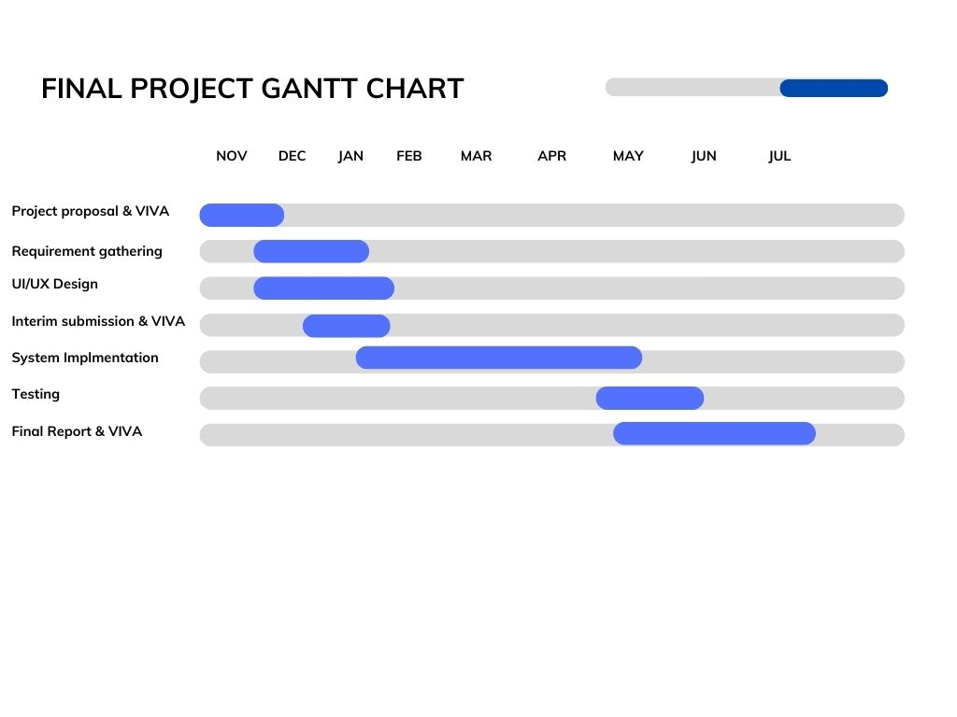Gantt Chart

Figure 2- Gantt Chart

Milestones

|  |  |
| --- | --- |
| Milestones | Month |
| Project proposal | November 2022 |
| Interim Submission | January 2022 |
| Project implementation | April 2022 |
| Final Report submission | June 2022 |
| Final Viva | July 2022 |

# Proposed Solution

**“Leisure Diary” Hassle-free all in one application**

Leisure Diary is the proposed solution for the identified significant problems and requirements addressed by the travelers and other service providers. The solution is a web based mobile application connected to an admin panel through a rest API technology. Application will have many entities such as Location accommodators (Hotels and resorts), transport providers, foods, other restaurants and other leisure activities. The solution is like a story creator which attracts the user’s interest with going forward with the application.

A user can register to the application by creating an account. The story begins the user can start to create the travel package. User can base locations, type of foods/restaurants or leisure activities as the initial point of selection. The application shows recommendations based on your interest. With adding the no of people to the system it filters the available options to proceed. After creating the whole story of the trip, you can share it among your co-travelers and other service providers on their approval of the reservations.

New features added-

* Each user can download a receipt containing a QR code after the confirmation received from the service provider.
* Each service provider can generate report of their customers and the list of customers.

**Identified entities**

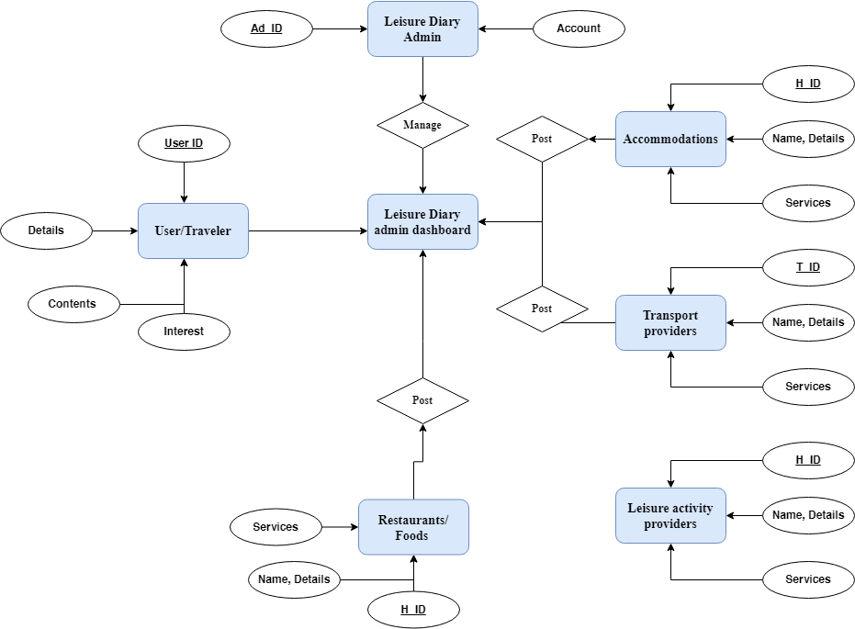

Figure - ER Diagram

**Simplified scope,**

* All-in-one travel app with social interaction. Transporters can interact with travelers; other businesses can interact with each other to expand their business.
* 6 types of accounts are to be included (Admin, Traveler, Accommodator, Transport provider, other leisure activity provider and food/restaurant).

**Travelers**

* Travelers get recommendations for accommodation, transportation, and other activities depending algorithm on their likeness and interest
* Travelers can post their posts and updates about their trips.
* Travelers can create a trip and share the plan.
* Can connect with others with a QR code. (Provide all the details).
* Geo Map to select and track the travel route. Get detailed report about the travel.
* Will receive a receipt with a QR code to interact with the service provider.

**Hotels and other leisure activities providers**

* Provide available services, facilities, related activities, and others.
* Connect and interact with clients through the application.
* Send offers to travelers.
* Promote the business to travelers and other services.
* Find transport services for their clients.
* Publish their posts in the feed (E.g., Offers and updates).
* Able to generate reports based on the number of reservations.

**Transport provider**

* Transport companies can send suggestions to travelers based on their route and No. of people.
* Provide the best solution based on customers' budgets and other requests.
* Connect to the traveler with their QR code and get their whole plan and reach the specific locations.
* Publish their posts in the feed (E.g., happy customer feedback).
* Able to generate reports based on the number of reservations.

**Potential evolutions**

* Language translator.
* Interacting option with their Travelers and service providers.
* Current update about the locations (Weather)
* Accounting system to track the spending and provide reports to others for transparent purposes.

## Suggested Starting Point

With the approval of the project proposal, Project will be starting from gathering information from travelers and related service providers and research and identify best possible UI/UX designs.

# Discussion

As our project scope is to interact with information provided by various aspects of entities. Information must be protected. As per the country law and other ethical aspects all the information and privacy must be protected. Since, all the entities provides their information the system is subject to protect their privacy, access rights other personal data.

Further major threat to be identified would be accuracy of the information provided by the service providers. Since the user and others get recommendations based on the information provided. Admin must have a procedure to ensure the reliability of the information provided by the stakeholders.

# 7. References

|  |  |
| --- | --- |
| [1] | N. F. P. L. S. K. a. T. S. N. Tavichaiyuth, Covid-19 Travel Planner Mobile Application Design with Lean Product Process Framework, 2022. |
| [2] | R. H. V.-V.-M. K. Roto V, Evaluating user experience of early product concepts Proceeding of the International Conference on Designing Pleasurable Products and Interfaces DPPI09, 2009. |

# Appendices

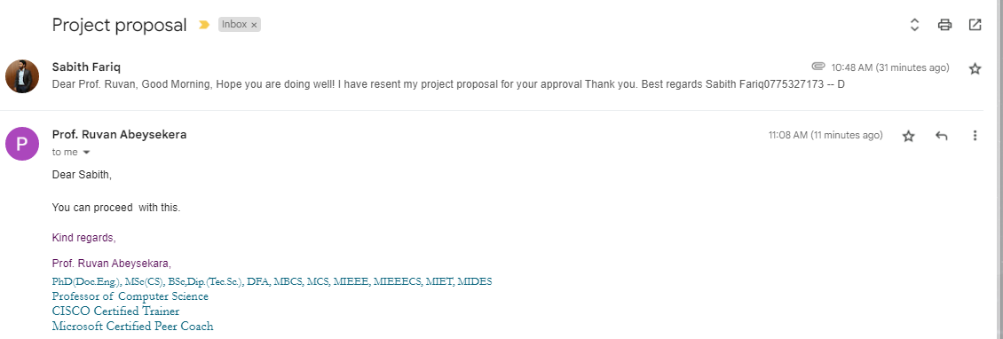

Figure - Project Proposal Approval by supervisor